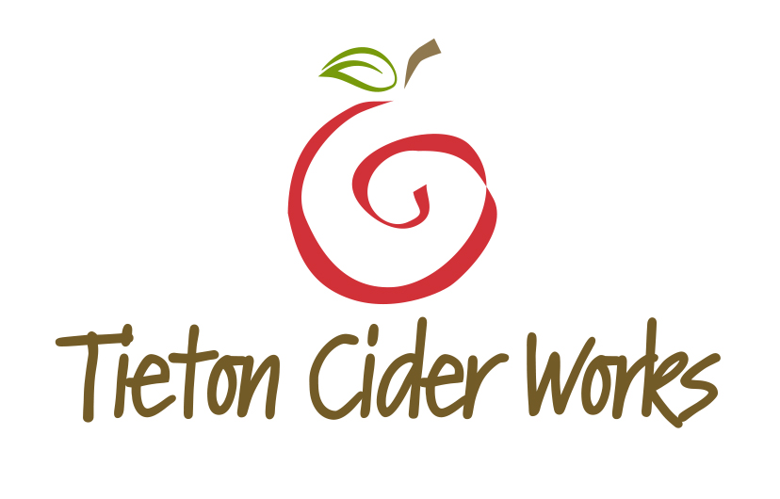
TIETON CIDER WORKS UNCORKS CIDERMAKER’S RESERVE AND SPARKLING PERRY
FOR IMMEDIATE RELEASE
Heidi Burmeister – Director of Marketing
Heidi@tietonciderworks.com
509-571-1430, ext. 102
www.tietonciderworks.com

Yakima, WA, April 2015 — Tieton Cider Works is hoping you uncork two of their most unique offerings, Cidermaker’s Reserve and Sparkling Perry. The Washington based artisan cider producer handcrafts these two items once per year, with production under 3,000 cases on both items combined. Releasing May 1, both offerings come dressed in a new package, complete with cork and cage, targeted specifically at high-end restaurants and gourmet dining.
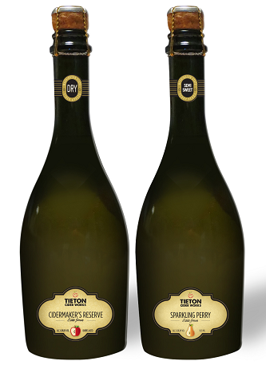
Cidermaker’s Reserve
“Cidermaker’s Reserve represents our very best”, says Cider Maker Marcus Robert. “We blend and age 40 different types of bitter-sharp and bitter-sweet apples in route to creating this cider. We ferment for over a year and compliment this aging process by utilizing bourbon barrels. The end result is a complexity rarely seen – exemplifying the meaning of craft cider.”
Sparkling Perry
“The authenticity of this drink might surprise you”, explains owner a third generation orchardist, Craig Campbell. “Not to be confused with pear cider, our Sparkling Perry is a blend of 11 different estate grown varieties of perry pears. A truly unique drink that rivals Champagne in in complexity and style. We feel strongly that perry pear is poised for a renaissance within the United States”.
Cidermaker’s Reserve remains the Mona Lisa of the Tieton Cider Works family of 13 different cider offerings. By studying and redefining proper growing regions for over 40 different styles of bitter-sharp and bitter-sweet apples, constantly blending to ensure rich and highly developed flavors, and patiently aging in hand-selected bourbon barrels, Cidermaker’s Reserve represents all the complexities you would expect to find within an estate grown, single-vineyard wine – without the hefty price.
“With so many sommeliers working so diligently to produce wine lists dedicated to the discovery of great, unusual and eclectic wines, we hope these key developers of unique categories start to embellish cider and its equally rich history and complexity,” explains Robert. “It only makes sense that great developers of beverage programs look deeper into the future and toward cider as the compliment to great wine, craft beer and spirits – not to mention food”.
The consumption of perry has a long, rich history, with well-established cases tracing back to just after the fall of the Roman Empire. Throughout several centuries, many countries have developed a strong association and equally diverse style for perry production. Whereas perry produced in England remains extremely dry and is often still served from cask, perry consumed in Normandy is generally sweeter in style and usually fermented in bottle. Tieton Cider Works prefers a balance somewhere between dry and sweet, with the primary goal being aimed at developing a unique food pairing. Authentic perry production (not pear cider) remains very limited within the United States, with only a handful of small producers reviving this historical beverage. (Remember, perry pears are not grown for commercial gain – and are only used in the production of authentic perry). This year, Tieton Cider Works will release a very limited quantity on draft (5.16 kegs) as they further hope to engage the craft world on the differences between commercial pear cider and authentic perry.
“Our Sparkling Perry Cider allows us to assist in the understanding and growth of one of the truly unique categories within the United States”, says Campbell. “The authentic perry category will be a much slower growing category than pear cider as there is an extreme shortage of these cultivars planted to ground. We hope lovers of sparkling beverages will take notice and see this as a perfect alternative to Champagne, Prosecco and Cava”.
Both Cidermaker’s Reserve and Sparkling Perry utilize a 500ml bottle and are distributed in 12-bottle cases. Pricing is lined on both items at approximately $9.99 - $10.99 per bottle with slight variances by distributor and state. All bitter-sharp and bitter-sweet apples, and perry pears are estate grown at the Campbell family farm called Harmony Orchards.
Tieton Cider Works welcomes you to visit their new 35,000 sq. ft. production facility and tasting room located in Yakima. There you will experience up to 13 different cider offerings from Tieton Cider Works (some being seasonal), along with Cidermaker’s Reserve and Sparkling Perry. The 1,000 sq. ft. bar and oversized conference room makes a great destination for socializing with Yakima locals, hosting private and corporate events or watching a ballgame. Opportunities to learn more about Tieton Cider Works orchards and production methods and tours can be booked by appointment.
Tieton Cider Works’ products are currently available in-store in 14 states—Washington, Oregon, California, Alaska, Idaho, Nevada, Arizona, Montana, Utah, New Mexico, Texas, Illinois, Florida and Hawaii. Also available in Vancouver, British Columbia, Canada.

Your search for a new celebratory beverage ends with Cidermaker’s Reserve and Sparkling Perry.

###

