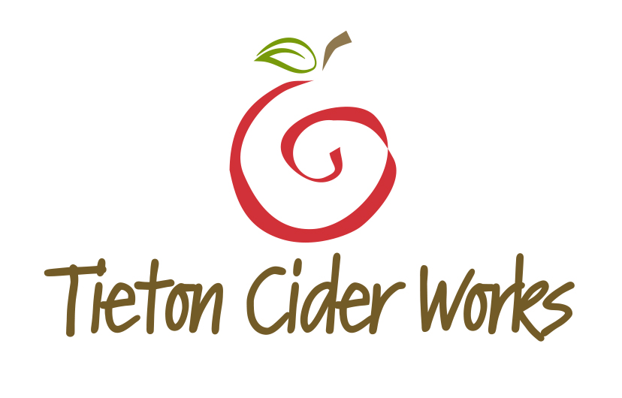
WASHINGTON BASED TIETON CIDER WORKS UNVEILS NEW LABELS IN MARCH 2015

FOR IMMEDIATE RELEASE
Heidi Burmeister
Director of Marketing
Heidi@tietonciderworks.com
509-571-1430, ext. 102
Yakima, WA, February 2015 — This month, Tieton Cider Works will unveil a new package design. The Washington State based, family owned company has been creating craft cider for 6 years and currently produces 13 different offerings. The new label design is targeted toward developing a strong sense of terroir – or “Tieton”, located in the heart of the Yakima Valley. Tieton’s new look will begin shipping to distributor partners in February and become available to restaurants and retailers in early March.
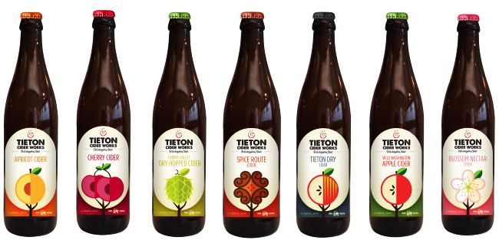
“Six years ago the craft cider business was virtually nonexistent,” explains owner and third generation orchardist, Craig Campbell. “Our original labels – with the word “cider” pronounced and centered– were designed to assist in the development of an entire category. With so many new brands entering the marketplace, we felt the need to focus on Tieton and Yakima – and their deep sense of place”.
Craig and Sharon Campbell own and operate nearly 400 acres of land, known affectionately as Harmony Orchards in Tieton (pronounced tie • uh • tun). They have been farming commercial apples, cherries, apricots and pears for over 30 years and selling to many stewards of high-end produce for equally as long. Then the cider-bug hit!
“We began to research the utter absence of bitter-sharp and bitter-sweet apples planted within the United States,” said Campbell. “And we decided that we would press forward and plant many varieties of these artisan cider producing apples while remaining loyal to craft production”.
Today, the Campbell Family has 40 different types of bitter-sharp and bitter-sweet apples planted, along with 11 types of Perry pears utilized to make their CAMRA certified Sparkling Perry, a Champagne-like drink poised for a renaissance. The Campbell Family orchards are far and wide and require a 30 minute drive time between plots of sprawling land. For the Campbell’s, and much like the way the wine industry boosts of a sense of place, their secret to great cider rests in the very ground they plant and manicure daily.
“Not too long ago people had a hard time pronouncing Willamette,” says Cider Maker Marcus Robert. “Today, the word Willamette is synonymous with the production of great wine – pinot noir and chardonnay in particular. We hope to someday have Tieton recognized in much the same manner throughout the world of cider.”
From a humble start, beginning with their flagship apple cider called Wild Washington, Tieton Cider Works has expanded and currently produces 7 core ciders, including Cherry, Apricot, Dry Hopped, Tieton Dry Blend, Blossom (a slightly sweeter cider ALSO releasing in March), and Spice Route (a new offering releasing in July). Seasonal ciders include, Smoked Pumpkin (releasing in July), Holiday Cheer (releasing in October), Frost (an ice-wine style cider released in October) and Wind (a port-style cider released in October).
Tieton Cider Works welcomes you to visit their new 35,000 sq. ft. production facility and tasting room located in Yakima for cider tastings. The 1,000 sq. ft. bar and oversized conference room makes a great destination for socializing with Yakima locals, hosting private and corporate events or watching a ballgame. But the new facility takes a backseat to the orchard tours available by appointment throughout Harmony Orchards.
The consistent visual theme on the new labels is of trees and fruit, emphasizing their commitment to orchard grown and locally sourced ingredients used in creating their cider selections. From farm to bottle, Tieton Cider Works micro-manages the entire process ensuring only the highest standard of quality. The “Farm Grown” logo further punctuates Tieton Cider Works commitment to the land they love and the ciders that represent their devotion to a special apple producing place known as Tieton.
Tieton Cider Works’ products are currently available in-store in 14 states—Washington, Oregon, California, Alaska, Idaho, Nevada, Arizona, Montana, Utah, New Mexico, Texas, Illinois, Florida and Hawaii. Also available in Vancouver, British Columbia, Canada.

###

