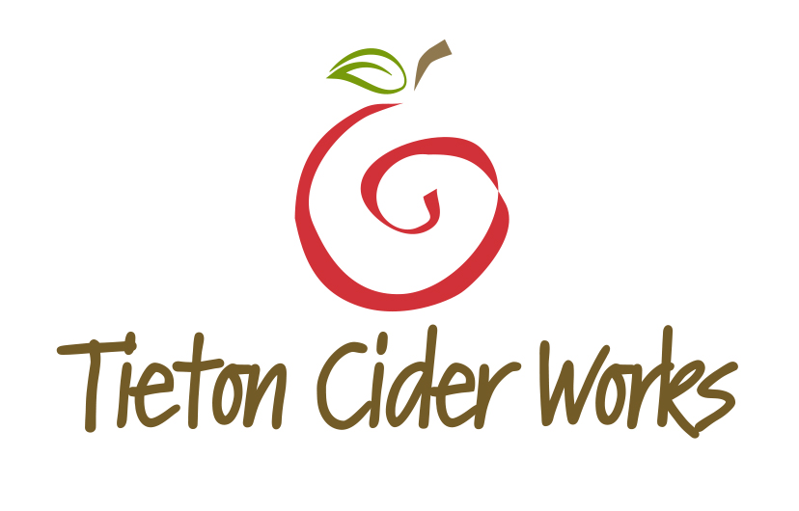
TIETON CIDER WORKS SPICES UP FALL WITH TWO CIDER RELEASES
SMOKED PUMPKIN AND SPICE ROUTE CIDERS RELEASING IN JULY
FOR IMMEDIATE RELEASE
Braden Andreas – VP of Marketing & Sales
Braden@tietonciderworks.com
(702) 540-3888
www.tietonciderworks.com

Yakima, WA, June 2015 — Tieton Cider Works is celebrating the changing of seasons with their 3rd release of Smoked Pumpkin Cider and the inaugural release of Spice Route Cider. The Washington based artisan cider producer will limit Smoked Pumpkin Cider to only 2,000 cases this year, while Spice Route Cider will become a core item available any time throughout the year. Releasing July 1, both offerings come dressed within Tieton Cider Works newly awarded label (package design). Both items offer a fantastic richness perfect for fall and transition perfectly into winter holidays like Thanksgiving and Christmas.
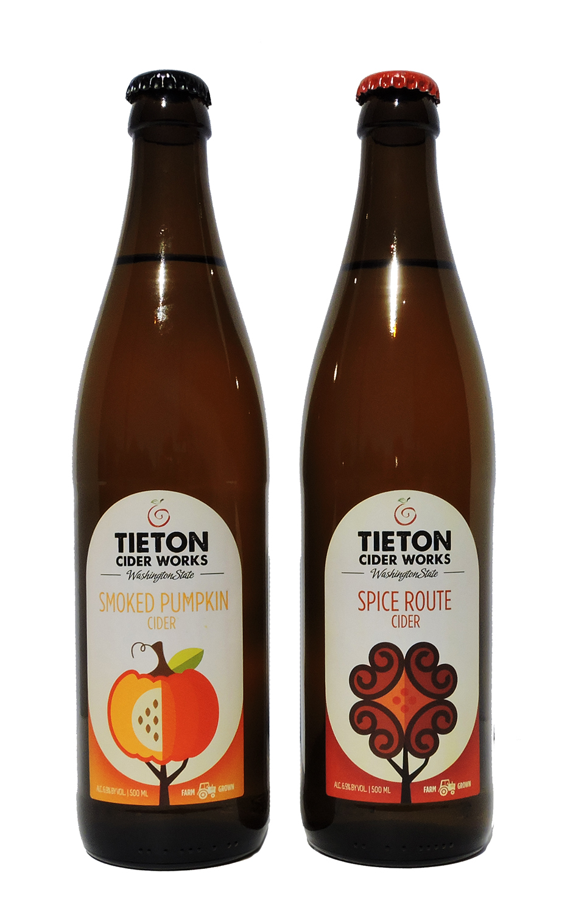
Smoked Pumpkin
“We try to encapsulate fall when we produce our Smoked Pumpkin Cider”, says Cider Maker Marcus Robert. “We begin with a uniquely bright cider, high in acid and tannin. We smoke that unique blend over the very same apple wood that produces our fruit and then infuse pumpkin to capture a natural earthiness. The end result is a bright gold pour that drinks slightly sweet, while capturing all the flavors of a perfect fall sipper.”
Spice Route
“Our goal was to create something exotic utilizing sweet spices,” explains owner and third generation orchardist, Craig Campbell. “Spice Route Cider is a very festive offering capturing flavors of cinnamon, vanilla, clove, allspice – and apple pie. When we finished the final blend we agreed this was a perfect fall release, but too unique not to produce year round as it pairs so uniquely with such a wide variety of cuisine.”
Smoked Pumpkin Cider utilizes a natural pumpkin sediment specifically sourced by Tieton Cider Works. Flavors are surprisingly natural and completely void of the sugar-sweetness that comes from many pumpkin products that use additives and artificial pumpkin flavorings. This year, Smoked Pumpkin Cider celebrates its second consecutive selection within the Total Wine Fall 2015 Seasonal Release Program, with product in stores in WA, CA, AZ, NV, NM, TX, and FL, from July 24 through October 27.

New to the Tieton Cider Works family of products is Spice Route Cider. A world of spices were explored in route to hand-crafting the final blend – a cider perfect for warm and cold weather. The versatility of this cider makes a perfect companion to barbeque anything, but it’s the rich and spicy components that make it a natural to compliment to your favorite ethnic food options. Spice Route Cider will be offered in both 1/6 and 1/2 barrel keg options.
Both Smoked Pumpkin Cider and Spice Route Cider utilize a 500ml bottle and are distributed in 12-bottle cases. Pricing is lined on both items at approximately $7.49 - $8.99 per bottle with slight variances by distributor and state. All bitter-sharp and bitter-sweet apples used within these offerings are grown at Harmony Orchards, the Campbell’s family farm.
Tieton Cider Works welcomes you to visit their new 35,000 sq. ft. production facility and tasting room located in Yakima to experience up to 13 different offerings from Tieton Cider Works (some being seasonal). The 1,000 sq. ft. bar and oversized conference room makes a great destination for socializing with Yakima locals, hosting private and corporate events or watching a ballgame. Opportunities to learn more about Tieton Cider Works orchards and production methods can be booked by appointment.
Tieton Cider Works’ products are currently available in-store in 15 states—Washington, Oregon, California, Idaho, Nevada, Arizona, Montana, Utah, New Mexico, Texas, Illinois, Michigan, Ohio, Colorado and Hawaii. Also available in Vancouver, British Columbia, Canada.

We hope you enjoy our fall releases of Smoked Pumpkin Cider and Spice Route Cider until every bottle cap is popped!

###

